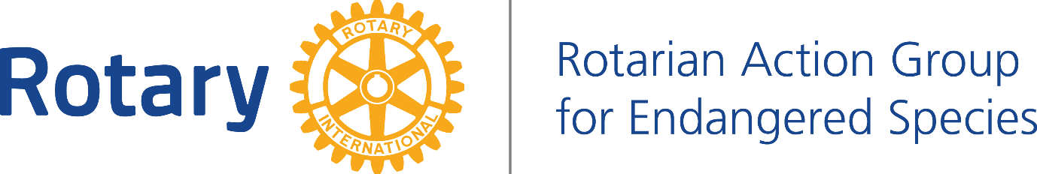

PROPOSED PARTNERSHIP WITH THE JANE GOODALL INSTITUTE KENYA AND RAGES.

THE WAY FORWARD.

After many months of discussion with Mary Lewis CEO Of the Jane Goodall Institute (JGI), and also the PA to Dr. Jane Goodall. Also the recent appointment of Jamey Ponte as Board member JGI Kenya. RAGES is now in a position to look at a partnership with the Jane Goodall Institute.

1- Introduction RAGES-JGI Conservation Library

We feel that the potential now exists for RAGES and JGI Kenya to launch a significant community project out of Kenya and by the 4th quarter 2016. Reaching the JGI East Africa region including Tanzania. Uganda, and the Democratic Republic of the Congo.

PILOT PROGRAMME

- PARTNERS IN PLACE:

RAGES, Local Kenya Rotary Clubs, Jane Goodall Institute Roots and Shoots Kenya, International sponsor Rotary Cubs and local community partners within the Wildlife areas of Kenya such as:

• KUAPO - Kenyan United Against Poaching.

•Working with one small rural community partner living among wildlife who have been in place with JGI Kenya for years. Suggest involvement of a school in the sponsor country in conjunction with their local Rotary Club in, say Australia.

- SCOPE OF PROJECT:

The project has many facets but simply works as a conduit to build rapport in rural areas living among wildlife that have proven hard to reach into the community structure.

JGI with Roots & Shoots Kenya have been working in local rural areas in Kenya since at least 2012 providing the local community to have a voice in conservation development.

At current the establishment system has little knowledge, interest or capacity to do the real work of building such relations. It will take many organizations and varied levels of leaders to build trust and rapport to realize stronger conservation practices that can be sustained and include modern day issues.

This work has been ongoing but struggles to have tools to be proactive but rather addresses hotspots in a more reactive manner chasing issues such as human wildlife conflict (HWC) and Poaching.

Relations not only remain weak in these cases but actually begin to build barriers as you can imagine if you have no prior rapport with a community and you come in only when you are asking who killed the elephant and your rangers are standing behind you with guns. Simply not a way to do much of anything that can help anyone or any effort to save wildlife or address best practices of land use.

JGI Kenya and RAGES develops a simple tool that helps build this rapport so when issues arise we already have a working relationship. This tool is the simple makings of varying levels of libraries.

- CONSERVATION LIBRARIES

- We start with the most basic level CONSERVATION BOX LIBRARY - simple wooden/metal box table that will house 50 or so books. Then it grows to:

- A CONSERVATION CORNER LIBRARY - 200/300 book version of above but more traditional bookshelves for the corner of any community structure. Which in turn becomes:

- A CONSERVATION WORKING LIBRARY - a structure that serves as library and educational outreach of a variety materials and workshops.

The entry must begin at the easiest level and least restricting per funds and on the ground resources. Fact of the matter is we are giving books to a community that has never had books and has no idea how to manage them. Allowing those partners above doing the conservation work to come and help educate about this new resource, replenish new books, have an icon/idol/tree to work from and begin this long process of the bigger issues of saving Endangered Species in a sustainable way that also address the people living among the wildlife with dignity.
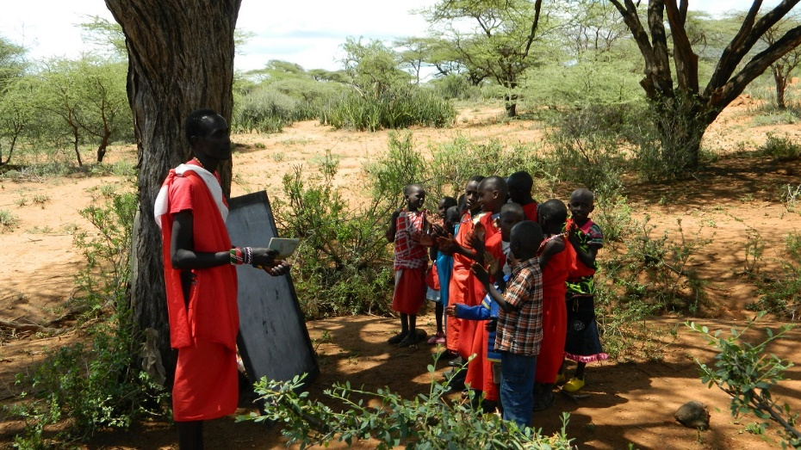

This project begins to programme the smallest community conservationist efforts to have ongoing relations. It even makes way for bigger establishments to behave better and encourages them to evolve in having these needed relations. It allows the marginalized to have a voice and to feel there is concern for all pillars to be included in the solution. Let’s just say it like this we feel you can make friends and break barriers with a book much easier than you can with a gun.

- FUNDING NEEDS

CONSERVATION BOX LIBRARY

One Sponsor Rotary Club is to invest in the launch of this in the amount of US$700 (70,000 Kenyan Shillings). This will allow full facilitation of at minimum of two or three Box Libraries to be started before mid-April 2016.

The holding of a mini-stakeholder meeting with the Board of the local Rotary club to understand and discuss the full potential of the project. It will include opportunities for local Rotarians to also participate by the collection of books, launching of a rural library, helping with ongoing restocking of that library.

Rotary volunteers (national/global) in producing community books specific for that community and having the book include mother tongue, Swahili, English all on each entry reader cultural story book, developing individuals to become ambassadors for the RAGES effort and finding securing new partners through this development to bring the community additional resources such as the:

CONSERVATION CORNER AND OR WORKING LIBRARIES.

- AVAILABLE RESOURCES.

JGI Kenya already have a small amount of books for the launch and can use a collection of books from the local Rotary Club and International sponsor club this first beta launch to happen prior to mid-April. Future collections can be made at Rotary meetings both locally and from the International Rotary sponsor club providing to buy some books we can easily have the first libraries well stocked and even have some back up books in place for restocking.

RAGES through their Australian Directors have enough funds to kick start this first prototype project. JGI through Roots & Shoots in Kenya have the village in place to be the beta test CONSERVATION BOX LIBRARY site.

- TIMELINE

APRIL 2nd 2016

Launch of the prototype project at our conference in Nairobi. We need RAGES and JGI Kenya to own this project and are committed- by having a presence at this 2nd April conference we can guarantee that exposure for us globally.

We will need RAGES through the local Kenyan Rotary Club or Clubs to make this happen. JGI Kenya invites RAGES to join them that day to bring books and have a Rotarian to share the project to the open community on the stage that day.

NOTES:

- JAMEY PONTE

Timing is critical per we have many things to build upon. I know Rotary is not a fast machine typically but I feel it can be in this case to secure Kenya’s role in the RAGES effort and to take advantage of all that is in play.

• RAGES mini-stakeholder meeting per IPDG Bimal Kantaria’s request
• Rotary book collection from initial funds of US$700 from Australia.
• April 2nd exposure of the RAGES effort locking it to Kenya launch
• two/three libraries in place by mid-April

* Development for Jamey and Pato key JGI R&S members to present and meet with USA Rotary Clubs. From mid-April through Mid-July.
• Jamey and Pato will be in Chicago for an event and lecture in May and can easily make a meeting with the RI office to share as well. This single project can give it that energy it needs to launch and we have a lot in play. Jane Goodall will even be here in Kenya mid-July- If RAGES and some Kenyan Rotary Clubs get on board and help me make this happen now I will make sure you have opportunity to host a Rotary dinner or whatever style meeting you want for Rotarians in July to bring major attention to RAGES and have Jane be keynote speaker.

- JOHN GLASSFORD AUSTRALIA

• RAGES board to host House of Friendship booth at RI global conference in South Korea.
• RAGES to bring full container of books here by 4th quarter 2016. (book/funding drives already in play)
• By end of year have at least 10 libraries in Kenya and at least 5 in additional East African neighbouring countries.
• 2017 prepare for full scale launch throughout Africa and South American countries.
• Have major presence booth/presentations at House of Friendship booth at RI Convention 2017 in Atlanta USA.

SUMMARY:

We are ready now why wait? RAGES JGI Kenya and Rotary in Kenya can easily lead this project. The first RI RAG to go beyond human rights. The first RAG to address Wildlife- this belongs in Kenya. We have strong long term partners in place and we have Jane Goodall not just on the team but standing with us very closely.

ACTION REQUIRED:

JGI KENYA & RAGES IN KENYA.

We need this to happen sooner but getting a handful of the right guys to come in from rural areas per dates is tough- We suggest to make things a bit more compact and to balance expenses we have them come in for a meeting on 30th March. This will be same time many are already coming in for a 1st April meeting for JGI R&S CORE and the 2nd April event - We Are Action.

We are Action 2nd April event- We have posters and flyers to share to anyone that has interest in spreading the word. This is an event we can stage the RAGES launch and make it work well. We are the producer of the event and what RAGES is doing is a direct fit. We need Rotary there in numbers. I need books collected not just from Rotarians but will make call out to all via social media and press release.

This history will strengthen RAGES and its Kenyan launch. I have major media that will cover the event and write about it. We would nominate RAGES Director IPDG Bimal Kantaria to represent RAGES.

We can also place the book drive info out there quickly as soon as we are given a green light from RAGES. We can even make a special flyer for all future Rotary meetings tying RAGES and the book drive to the 2nd April event. But timing is now. Jamey is available to go to meetings to do three minute talk on the RAGES book drive even from now through end of March.

Jamey is also prepared to join Rotary a local Kenyan Rotary Club

REFERENCES:

Facebook: https://web.facebook.com/events/1079773465408386/ Jamey can answer any questions we have about this event and how Rotary can be a partner.

Here is an article from the conference that this event is a follow up to:

http://www.cisanewsafrica.com/kenya-tackling-social-injustice-is-everyones-responsibility-says-conservationist/

