

The Keyway

ROTARY CLUB OF WAGGA WAGGA SUNRISE Inc.
DISTRICT 9700
PO Box 5430 Wagga Wagga 2650 NSW

Meeting Venue: Thyme Out Restaurant, The Manor, 38 Morrow Street, Wagga Wagga
Meeting Time: Breakfast 7.00am for 7.15am, completed by 8.30am

28 February 2012
February is World Understanding Month

GUEST SPEAKER: Arupam Raman: National Youth Science Forum 2012
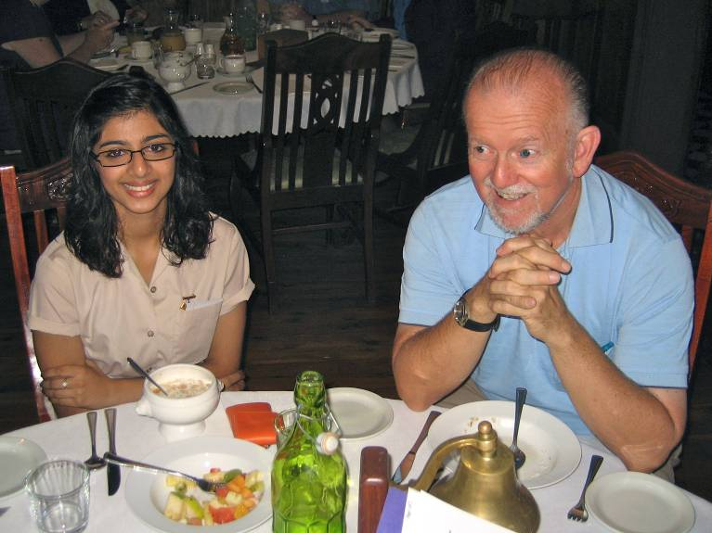
ATTENDANCE NO: 33
APOLOGIES: Helen Allen, Bernie Benson, Andrea Bradley, David Brady, Yvonne Braid, Peter Brown, Noelene Hogan, Fred Loneragan, Sue McAlpin.

VISITING ROTARIANS: AG Gary Roberts, Peter Keith (Kooringal) & David Dunn (South WW – see left, with Arupam Raman)

LEAVE: Dawn Smith, Jan Gray, Anne Pattison.

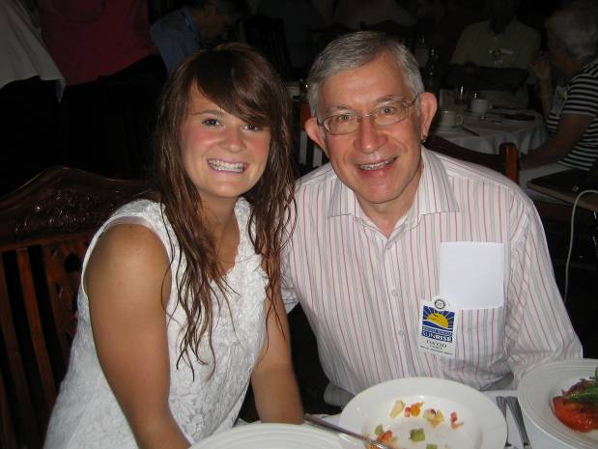
GUESTS: Leonie Roberson (a welcome return), Stephanie Muir (The Leader – see below, with David Gilbey) & Arupam Raman (Kooringal High School).

BIRTHDAYS: Joe Fealy 28 Feb

ANNIVERSARIES: Sue and Max Chapman 4 March

COMing events/Fund raisers:
- ‘Coota Bike Festival’ Rotary Club of Cootamundra is hosting the festival, March 10 -11.
- Science and Engineering challenge, March 20th
- RYDA, Tuesday 27th March
- BBQ Driver Awareness at Equex, Friday 30th March
- District Conference at Young, 23rd to 25th March
- Host GSE team, five members 28th March to 1st April.

president’s Report: by Alan Sharp.
- Rotary International President, Kalyan Banerjee, will be visiting our District on Tuesday 22nd May 2012. A dinner is planned for Tuesday evening and is being organised by Wagga Wagga Rotary Club. The District Board is planning a mass induction of new members by the RI President. (pic below: AG Gary Roberts enjoys a muffin while Alan speaks)
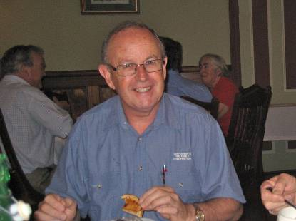
- The 100 day District Membership Growth Challenge has been adopted by the District Board. I have asked that the details be added to this week’s Keyway so that all members have all the details (see below, after the Roster – ed.).
- The Club was well represented at the Polio Plus fundraising movie with $3039.00 being raised by the evening for the project.
- John Mueller has written to thank Sunrise Rotary for the Club’s nomination for his Peace Award.
- Rotary District 9700 Conference 24th-25th March, in Young.

SECRETARY’S REPORT: Marilyn Walter (including last week’s correspondence which your apologetic editor amnesially omitted – apologies):
INWARD
Charles Sturt University | Invitation to President to view Town and Gown Academic Procession 29 March 5 pm and reception afterwards
Glamis Court Florist | Account for D. Smith’s flowers
Australian Rotary Health | Hat Day to raise money for Mental Health Research 18 May – craziness encouraged!
Australia Post | Account for post box
Rotary Club of Cootamundra | Coota Bike Festival 10-11 March
Fountaindale Grand Manor, Robertson | Christmas in July available
DG Ian Simpson | Grow Rotary D9700 – 100 members in 100 days
Barry O’Farrell | Invitation to Community Meeting 1 March 1-2.30pm MTC
Australian Rotary Foundation Trust | Tax receipts for members’ donations
OUTWARD
Donation of $500 has been made to D9700 Partners’ Program (Jean Simpson) for purchase of 4 Street Swags for the homeless in the Wagga area and 15 Water Filter Systems for the households in the villages of the Luro region in Timor Leste.

DIRECTORS’ etc REPORTS:
Community Services, David O’Grady:
A reminder to all members to participate in Clean-Up Australia Day on Sunday 4th March. Would members please meet at the truck-parking bay just around the corner from The Silvalite, on the Olympic Way, on Sunday morning @ 0800 hrs.
Youth, Peter Gissing:
- Members are required to assist at The Rotary Science & Engineering School on Tuesday 20th March from 0900-1500 hrs.
- Members are also required to assist @ RYDA on Tuesday 27th March from 0900-1500 hrs.
- Our Club is also providing the BBQ lunch @ RYDA on Friday 30th March from 1100-1330 hrs (approx.). Volunteers are sought to assist with the BBQ.
Incoming President, Val Samuelson:
- Val’s report was about her attendance at PETS last weekend in Young. It was pleasing to see Sunrise Rotary so well represented, as Fred Loneragan, Peter Gissing and Noelene Hogan also attended. One main theme discussed on the weekend was that Rotary is all about having fun.
- The new office bearers are to be inducted on 29th April at Grenfell. All Members are warmly invited to attend.
GSE news, Bob Martin:
As Wagga is hosting a visit by the GSE team from Scotland at the end of March, accommodation is required for one member of this team for four nights. Please see Bob should you be able to welcome one of the team members into your home.

SERGEANT-AT-ARMS: Once again were we very well entertained by Patrick Ball this morning:
- Jennifer was fined for wanting to sit at an “intelligent” table thereby lacking in discernment by sitting with Patrick!
- Len was then in the spotlight for having driven through an amber light in Canberra, while Patrick stopped.
- those who didn’t know Coca-Cola-Amatill is the major reason for Clean-Up Australia.
- Those having eaten the delicious mushrooms at breakfast. Followed by some new trivia informing us that the main cause of injury to mushroom-pickers in Europe is falling out of trees!
- Members not attending the movie night were fined.
- Also those members not participating in Clean-Up Australia.
- We were all reminded about, and concurrently fined, the 100-Day Challenge for new members.
Cross fines: Val fined Patrick for lack of comprehensive research, having only used today’s news & recent events for his fine session.
FINES: $71.45

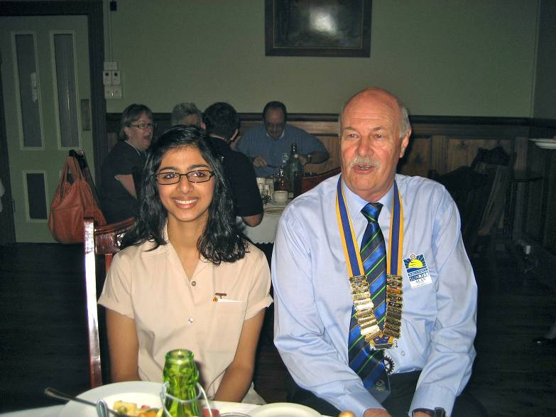
GUEST SPEAKER: Our guest speaker this morning was Arupam Raman from Kooringal High School. Peter Gissing introduced Arupam as the student sponsored by Sunrise Rotary to attend the National Youth Science Forum held in Canberra January last. Arupam gave us a thorough overview of the Forum by power-point presentation while outlining the activities and events which she obviously enjoyed.
The objective of the Forum was to give senior high school students exposure to a wide range of possible careers in science. This year’s Forum took place in Canberra for a week from the 2nd January. 144 students attended from all over Australia, including international students from New Zealand, Germany and Canada.
During the week of activities the students toured The Australian War Memorial, participated in a mock debate at Old Parliament House, visited The Australian Institute of Sport and Questacon.
On campus at The Australian National University the students were taken into chemistry, pathology and pharmacology laboratories and even given the opportunity to make some menthol cream. They attended seminars with regard to completing Year 12, the Higher School Certificate and attending University. The Applied Science Building was visited including an organ museum, also the Physics Building to see a particle accelerator and laser seminar. In the Earth Science Department they were introduced to seismographs, handled a meteorite and saw a trilobite fossil.
As well as all the above academia the students were treated to warm home hospitality by Rotarians, held forum debates and had much fun at evening activities including a music concert. They were assisted with job applications and interviews, impromptu and prepared speeches.
It was apparent that the Forum was thoroughly informative and at the same time highly entertaining, with new friends being made. Arupam said she arrived at the Forum thinking that she knew everything and left feeling like she knew nothing! The picture that she had of her future is now much more complicated, which she agrees is positive.
David Gilbey thanked Arupam for her extremely interesting and well-planned presentation. He also broached the subject of numbers of male students being far fewer than female, which Arupam verified.

BARRELL DRAW: Bob Martin won the wine.

MEETING CLOSED: 8.30 am

Roster for March
Date | 6th March | 13th March | 20th March | 27th March
Venue | Thyme Out | Thyme Out | Thyme Out | Thyme Out
Meet & Greet | Ndungi Mungai | Dave O'Grady | John Wood | Joan Skews
Meeting setup | Alan Sharp | Alan Sharp | Alan Sharp | Alan Sharp
Meeting pack up | Bernie Benson | Max Chapman | Deborah Braines | Yvonne Braid
Attendance Desk | Denise Flockton | Jo Wilson | Tim Stait | Dawn Smith
 | Patrick Ball | Len Wade | Darren Verus | Marie Wood
Sergeant-at-Arms | Dennis Blackett | Jo Wilson | Peter Brown | Patrick Ball
Bulletin Reporter | David Brady | David Brady | Bob Martin | Bob Martin
Program | Catherine Harvie Irene Gleeson Foundation | Men's Shed  BBQ | Crissey Brunskill  Digital Switchover | Club Assembly
Introduce Speaker | David Gilbey |  | Peter Brown
Thank Speaker | Max Chapman | Dizzy Desailly | Denise Flockton

**Reminder: If you are rostered on for a job but can’t make the meeting, please make arrangements for someone to replace you .

Letter from DG Ian Simpson re the 100 Day Membership Challenge

Dear Members,
In early January 2012 a group of District leaders and Club members committed to membership growth met to discuss how we as a District could grow our membership in the remainder of the 2011-12 Rotary Year.
The overall aim is to:
- Grow District 9700 membership to 1200+ members by 1 July 2012 (Target 1300) ;
- Avoid being subjected to Re-Districting by the Rotary International Board; and
- Ensure that DGN Geoff Tancred becomes District 9700 Governor in 2013-14
A BOLD Plan has been developed and released to the Presidents Elect at PETS Training over the weekend. The plan is for a concentrated 100 day focus on membership growth across our District.
The plan is titled: “Grow Rotary D9700” Challenge - 100 Members in 100 Days
Start date: 1st March 2012 Finish Date: 8th June 2012
Click here for the Discussion Paper providing you with details of the proposal.
BREAKING NEWS
On Friday I was informed that Rotary International President Kalyan Banerjee will be visiting our District on Tuesday, 22nd May 2012.
This visit is part of a 'fly-in & fly-out' whistle stop tour to Canberra - Wagga - Dubbo in a week for unspecified purposes. We are planning a big (300) Welcome to District 9700 Dinner in Wagga for the Tuesday evening. This will be organised by Wagga Wagga Rotary, our 1st Club.
This is a great opportunity for us to impress our current Rotary International President (and Chairman of the Board of Rotary International) by showcasing our District's strength and dedication to Rotary and it Ideals.
Mass Induction of New Rotary Members
One way to make a strong impression will be in the area of membership growth. To achieve this, the District Board is planning a 'Mass Induction' of new (30-50+) Rotary members by our International President at the Dinner on 22nd May.
I am therefore asking all Rotarians to make a Special Effort to recruit new members for their induction by RIP Kalyan Banarjee at this meeting. All members in the District will be invited to this dinner to witness the induction of new members from across the District.
This visit is a unique and exciting opportunity and if we want our District to retain its rural focus then this is the time to 'Have a Go' at growing our membership and making our Clubs BIGGER & BETTER positioned for the future of this great organisation to which we belong.
Yours in Rotary Service
Ian
Ian Simpson (Jean)
Rotary District 9700 Governor for 2011-12
Reach Within to Embrace Humanity
PO Box 9009
EAST ORANGE NSW 2800
Ph. 61 2 6361 4491
Fax. 61 2 6361 2862
Mob. 0419 978 996

.................................................................................................................. Board Members 2011/2012:
President: Alan Sharp Secretary: Marilyn Walter
Treasurer: Sandra Rootes President Elect: Val Samuelson
Club Administration: Val Samuelson Rotary Foundation: Noelene Hogan
Membership/Vocational: Jo Wilson Public Relations: Yvonne Braid Service Projects: Dave O’Grady Youth: Peter Gissing Immediate Past President: Denise Flockton
New Members Inducted 2011:
Len Wade, Helen Allen, Dominic Ferlito, Ndungi Mungai, Tessa Bremner, Ian MacDonald.
District Governor: Ian Simpson & Jean [Rotary Club of Orange North]
Assistant Governor: Gary Roberts [Rotary Club of Wagga Wagga Murrumbidgee]
Club Members involved at District Level:
Director, District Foundation: Fred Loneragan (Rotary Foundation)
Director, District Rotary Service Projects: Noelene Hogan
District Chairperson: Fred Loneragan (Rotarians Fighting for Aids, Peace Communities)
District Committees: Noelene Hogan (Director, District Rotary Service Projects) Marilyn Walter (Rotarians Fighting For Aids)
Denise Flockton (Vocational Services & Awards)
International Peace Communities Conference: Fred Loneragan (Chairman), David Gilbey

THE FOUR WAY TEST:
Is it the TRUTH?
Is it FAIR to all concerned?
Will it build GOODWILL and BETTER FRIENDSHIPS?
Will it be BENEFICIAL to all concerned?

final drollery: …thanks Helen:

RETARDED GRANDPARENTS---
After Christmas, a teacher asked her young pupils to write an essay on how they
Spent their holiday away from school.
One child wrote the following:
We always used to spend the holidays with Grandma and Grandpa.
They used to live in a big brick house but Grandpa got retarded and they moved
To Batemans Bay where everyone lives in nice little houses, and so they don't
Have to mow the grass anymore!
They ride around on their bicycles and scooters and wear name tags because they
Don't know who they are anymore.
They go to a building called a wreck center, but they must have got it fixed
Because it is all okay now. They do exercises there, but they don't do them very
Well.
There is a swimming pool too, but they all jump up and down in it with hats on.
At their gate, there is a doll house with a little old man sitting in it. He
Watches all day so nobody can escape. Sometimes they sneak out, and go cruising
In their golf carts!
Nobody there cooks, they just eat out. And, they eat the same thing every night
--- early birds.
Some of the people can't get out past the man in the doll house. The ones who
Do get out, bring food back to the wrecked center for pot luck.
My Grandma says that Grandpa worked all his life to earn his retardment and says I should work hard so I can be retarded someday too.
When I earn my retardment, I want to be the man in the doll house. Then I will
Let people out, so they can visit their grandchildren.

Bulletin Reporter: Jennifer Weale
Keyway Editor: David Gilbey

