

The Keyway

ROTARY CLUB OF WAGGA WAGGA SUNRISE Inc.
DISTRICT 9700
PO Box 5430 Wagga Wagga 2650 NSW

Meeting Venue: Thyme Out Restaurant, The Manor, 38 Morrow Street, Wagga Wagga
Meeting Time: Breakfast 7.00am for 7.15am, completed by 8.30am

24 January 2012
January is Rotary Awareness Month
ATTENDANCE NO: 31
APOLOGIES: Sue McAlpin, Ndungi Mungai, Dave O’Grady, Alan Sharp, Darren Verus, Marilyn Walter.

LEAVE: Jan Gray, Anne Pattison.

GUEST SPEAKER: Helen Allen: Report on US Cereal Conference

VISITING ROTARIANS : Rob Byrne, Grafton (see below: outside Thyme Out, with bike & Peter Gissing, Bill O’Rourke & Marie Wood).
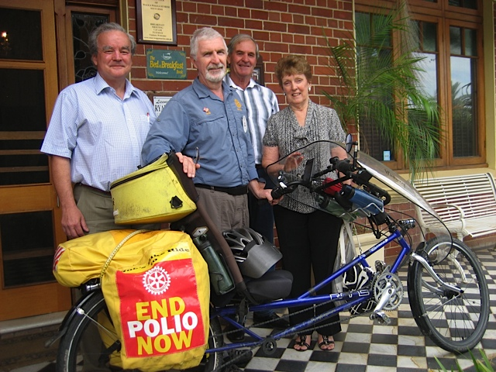
ANNIVERSARY/S: Bob and Carol Martin, 43 years.

COMing events/Fund raisers:
- Next week’s meeting is a vocational evening at Kurrajong Recycling, beginning 5.30pm (see below)
- RAWCS meeting to be held on 4th and 5th Feb at Cowra Bowling Club
- Rotary Peace Ceremony at Victory Memorial Gardens 19 Feb
- District Conference at Young 23rd to 25th March
- Host GSE team, 5 members 28th March to 1st April.

president’s Report: Denise Flockton acting in Alan Sharp’s absence.
Denise reminded us of the coming events noted above.
She also introduced Rob Byrne, from Grafton. Rob Byrne spoke on his bike ride from Grafton to Cairns the long way, visiting 81 clubs so far in 4000kms to push for more money for Polio Plus.
We have a short fall in the needed budget to eradicate polio by 20% the last few years. This year so far we only have 40% of the 1Billion needed.
We need to stop the shortfall to eradicate before it returns.

Patrick presented Rob with a Sunrise mug and certificate.

SECRETARY’S REPORT: - nothing of significance.

Treasurer’s reporT: none

DIRECTORS’ REPORTS:
- Jo Wilson reminded us that next week’s meeting is a vocational evening meeting at Kurrajong Recycling on 31st Jan, 5.30 pm at Chaston Street, to be followed by a dinner at the Sportsmen’s Club Hotel, cnr Kincaid & Beckwith sts, @ $10 per person.
- Noelene Hogan urged people to consider attending the RAWCS conference in Cowra, 4-5 Feb where regional programs will be discussed, and to consider attending the District Conference at Young, 23-5March.
- Peter Gissing noted that the website is up and active and that The Keyway will be uploaded there: www.rotarywaggasunrise.com.au
- Fred Loneragan mentioned the movie night for later in Feb to raise money for Polio Plus. $20 per head, $9 goes to Polio Plus.

SERGEANT-AT-ARMS: Bronwyn Hills’ maiden performance asked questions, and fined:
What year was the first Australian Open? 1905
What year was the first Women’s Australian Open? 1922
Anyone not wearing green & gold
Anyone wearing red white and blue.
Peter Brown for dangerous gardening (three cracked ribs)
Helen Allen for guarding keys for 24 men at the beach.
John Wood for walking around the beach (looking for his keys?)
Anyone that doesn’t own a four-legged friend.
Dennis for being late for Meet & Greet
Anyone who hasn’t bought or sold property in the last month.
X Fines
Patrick Ball fined NSW Police Force for Breath Testing him four times in one night between Harden and The Rock. He passed every time!

FINES: $70.15

GUEST SPEAKER – Bob Martin introduced Helen Allen as ‘one of ours’ who had been to a conference in Palm Springs, California, for Cereal Chemists.

The major issues for the conference were:
- Whole grain cereals and Health
- Increasing fibre in the diet
- Using whole grain cereals
- To help fight against diabetes and heart disease
- To improve colon health and reduce bowel cancer

A major problem in the US is obesity and a big reason is the ‘Drive Thru Everything’ and the lack of cooking at home.
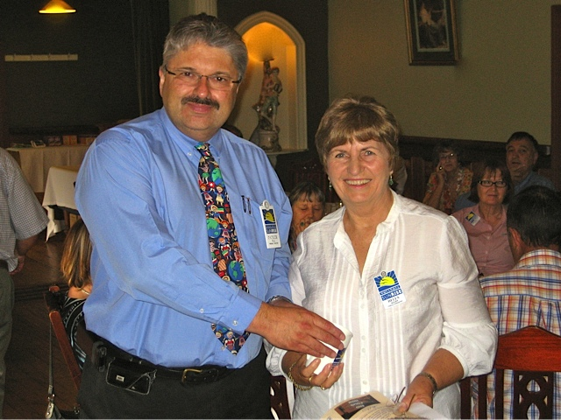
It is recommended that we need 35g per day of dietary fibre. Americans have 15g, Australians have less than 20g with the Germans the highest at 20g per person per day.
To get more dietary fibre we need to eat less white bread which is made of highly refined flour and eat more wholemeal or better still whole grain breads. Also different grains are better for different parts of the digestive tract so eat multi grain breads and breakfast cereals.

Helen summed up “to fight diabetes in Australia”:
Eat less
Choose less processed foods
Lose weight
Exercise at least 30 mins per day.
(pic above: Patrick Ball presents Helen with Sunrise mug & certificate)

BARRELL DRAW: Noelene Hogan won the wine.

MEETING CLOSED: 8.30 am.
Roster for January/February
Date | 31st January | 7th February | 14th February | 21st
Venue | Kurrajong Recycling | Thyme Out | Thyme Out | Thyme Out
Meet & Greet | Vicki Richards | Gordon Moore | Leslie Scott | Jo Wilson
Meeting setup | Alan Sharp | Alan Sharp | Alan Sharp | Alan Sharp
Meeting pack up | Max Chapman | Marie Wood | Tim Stait | Dawn Smith
Attendance Desk | Bob Martin | Bill O'Rourke | Dave O'Grady | Noelene Hogan
 | Fred Loneragan | Francis Desailly | David Brady | Andrea Bradley
Sergeant-at-Arms | Denise Flockton | Peter Brown | David Gilbey | Tim Stait
Bulletin Reporter | Jennifer Weale | Darren Verus | Jennifer Weale | Helen Allen
Program | Vocational meeting | tba | tba | tba
 | Dinner: Sportsmen’s Club
Introduce Speaker |  | Dennis Blackett | Fred Loneragan | Yvonne Braid
Thank Speaker |  | Len Wade | Andrea Bradley | Ndungi Mundai

**Reminder: If you are rostered on for a job but can’t make the meeting, please make arrangements for someone to replace you .

.................................................................................................................. Board Members 2011/2012:
President: Alan Sharp Secretary: Marilyn Walter
Treasurer: Sandra Rootes President Elect: Val Samuelson
Club Administration: Val Samuelson Rotary Foundation: Noelene Hogan
Membership/Vocational: Jo Wilson Public Relations: Yvonne Braid Service Projects: Dave O’Grady Youth: Peter Gissing Immediate Past President: Denise Flockton
New Members Inducted 2011:
Len Wade, Helen Allen, Dominic Ferlito, Ndungi Mungai, Tessa Bremner, Ian MacDonald.
District Governor: Ian Simpson & Jean [Rotary Club of Orange North]
Assistant Governor: Gary Roberts [Rotary Club of Wagga Wagga Murrumbidgee]
Club Members involved at District Level:
Director, District Foundation: Fred Loneragan (Rotary Foundation)
Director, District Rotary Service Projects: Noelene Hogan
District Chairperson: Fred Loneragan (Rotarians Fighting for Aids, Peace Communities)
District Committees: Noelene Hogan (Director, District Rotary Service Projects) Marilyn Walter (Rotarians Fighting For Aids)
Denise Flockton (Vocational Services & Awards)
International Peace Communities Conference: Fred Loneragan (Chairman), David Gilbey

THE FOUR WAY TEST:
Is it the TRUTH?
Is it FAIR to all concerned?
Will it build GOODWILL and BETTER FRIENDSHIPS?
Will it be BENEFICIAL to all concerned?

final drollery: thanks Helen Allen
They Ask Why l Like Retirement !!!
Question: How many days in a week?
Answer: 6 Saturdays, 1 Sunday.
Question: When is a retiree's bedtime?
Answer: Three hours after he falls asleep on the couch.
Question: How many retirees to change a light bulb?
Answer: Only one, but it might take all day.
Question: What's the biggest gripe of retirees?
Answer: There is not enough time to get everything done.
Question: Why don't retirees mind being called Seniors?
Answer: The term comes with a 10% discount.
Question: Among retirees what is considered formal attire?
Answer: Tied shoes.
Question: Why do retirees count pennies?
Answer: They are the only ones who have the time.
Question: What is the common term for someone who enjoys work and refuses to retire?
Answer: NUTS!
Question: Why are retirees so slow to clean out the basement, attic or garage?
Answer: They know that as soon as they do, one of their adult kids will want to store stuff there.
Question: What do retirees call a long lunch?
Answer: Normal .
Question: What is the best way to describe retirement?
Answer: The never ending Coffee Break.
Question: What's the biggest advantage of going back to school as a retiree?
Answer: If you cut classes, no one calls your parents.
Question: Why does a retiree often say he doesn't miss work, but misses the people he used to work with?
Answer: He is too polite to tell the whole truth.
And, my very favorite....
QUESTION: What do you do all week?
Answer: Monday through Friday, NOTHING..... Saturday & Sunday, I rest.
Bulletin Reporter: Max Chapman
Keyway Editor: David Gilbey

