**PETER FARR D1010 GSE TEAM LEADER 2012**

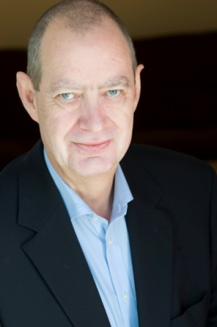I was born and grew up in Melbourne and graduated from Monash University with a science degree. Following a period of teaching science in rural Victoria I joined the Royal Australian Air Force and was posted initially to RAAF Base Wagga and then to RAAF Base Point Cook in Melbourne. Following my service in the RAAF I joined the School of Applied Science at the Royal Melbourne Institute of Technology teaching TAFE students. Still at RMIT I moved to the TAFE Off-campus Co-ordinating Authority where I managed the delivery of TAFE courses throughout Victoria by the Off-campus mode.

Work took me to England and later to Dunblane, Scotland, where I now live. Following jobs with Barclays Bank, the Benefits Agency and Central Regional Council in Stirling, I spent 12 years with the UK Department for International Development as Head of Training, retiring from the Civil Service in 2008.

I joined Rotary three years ago in District 1010 where I am a member of the Bridge of Allan and Dunblane Club and Vice Chair of the Community and Vocational Committee.

Since retiring I have also had time to indulge my interests that include travel, ornithology, film, art, aviation and classic Italian sports cars although regrettably I don’t own one. I have been married to Veryan for 32 years. We have two children: Nicola, 28, who is a primary teacher in London and Andrew, 27, who is a photographer based in Uganda.

In terms of vocational interests during the exchange I am interested in governance issues, in particular state and local government and the relationship between them and how that relationship affects Federal matters.

Having served at RAFF Base Wagga I should like to visit the base and pay a courtesy call if that could be arranged.

And finally I am most eager to learn about Rotary in the Riverina.

**Peter Farr**

**Rotary District 1010 GSE Team Leader 2012**

**36 Menteith View |Dunblane  FK15 0PD |United Kingdom**

**Voice: +44 (0) 1786 825 507 |Mob: +44 (0) 7757 062810**

**Email:** [**peter_farr@hotmail.co.uk**](mailto:peter_farr@hotmail.co.uk) **Blog:** [**http://scotwag.blogspot.com/**](http://scotwag.blogspot.com/)

**AMANDA INGRAM - D1010 Team Member**

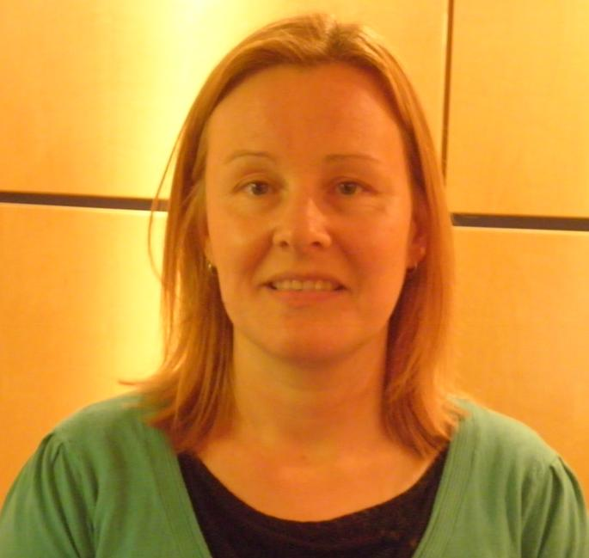I grew up in a rural part of Aberdeenshire in the North East of Scotland and after spending several years working in various places in the UK and abroad I now live in and work in Aberdeenshire again. Following school, I completed a BSc in Environmental Geography in Aberdeen and then worked for a Conservation Organisation in Ghana for one year before undertaking an MSc in Environmental Protection and Management in Edinburgh. My interest in environmental issues and in particular waste management have led me to have a varied career including; undertaking waste audits for the public and private sector; assisting and advising small businesses to improve their environmental performance; developing communication and publicity materials; and managing large scale media campaigns on behalf of Local Authorities. I know rubbish isn’t everyone’s idea of fun but my current position as the Waste Management Officer for Aberdeenshire Council is my idea of a dream job! With 14,000 staff and over 600 premises providing services from schools and leisure facilities to landscaping and country parks, I manage the development and undertaking of a waste management campaign across all council premises. This involves identifying and implementing new services, delivering talks to staff, pupils and stakeholders and developing communication materials to raise staff awareness, encourage good practice and achieve better waste management across the council.

Some may say I have an unhealthy interest in waste – much of my house is furnished with items I have reclaimed from second hand stores or skips, my holiday snaps usually include a few bin pictures and I travelled to Sierra Leone recently to spend 2 weeks undertaking volunteer work with local residents on a landfill site.

However, when I am not rummaging in skips and landfill sites I love spending time outdoors usually up a mountain or cycling, travelling or getting snap-happy with my camera. I play basketball for a local team, volunteer as a first-aider with the Red Cross and provide short-term respite care for a young child. I love trying new things and am currently learning to ice skate. I come from a large family and enjoy spending time with them all – even if my nieces and nephew do use me as a climbing frame and create mayhem in my house when they come to stay!

It would be of great interest to me personally and in a work capacity to have an opportunity to work with staff and organisations involved in various waste management issues from the local collection and treatment of waste to the wider strategic development and enforcement of regulations. In particular, I hope to learn more about the services, initiatives, resources and campaign materials being used to enable participation and increase awareness of opportunities to reduce, reuse, recycle and compost to residents, pupils and businesses across New South Wales.

Waste Management is a fast moving industry and there are many similarities in the challenges that face NSW and Aberdeenshire. I look forward to sharing ideas and experiences that could be replicated both in NSW and Aberdeenshire.

**Amanda Ingram, Rotary District 1010 Team Member**

**Personal: amanda_d_i@hotmail.com Tel: 07789 745659**

**Work: amanda.ingram@aberdeenshire.gov.uk Tel: 01467 628680**

**ANNE SUTHERLAND – District 1010 Team Member**

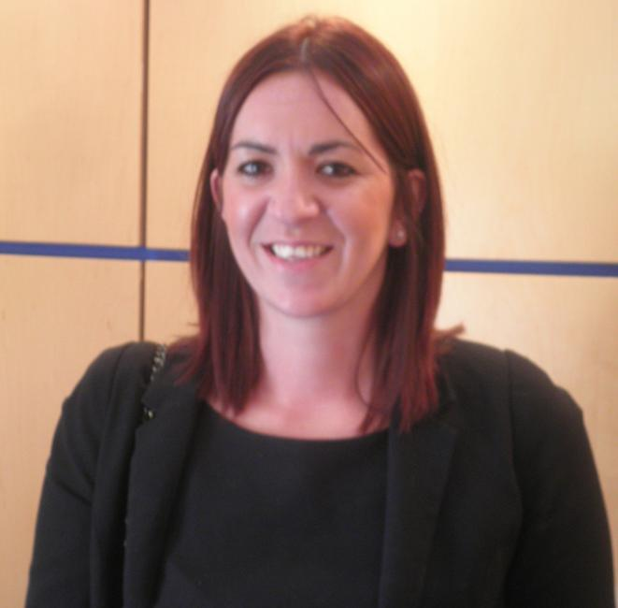

I am currently working as Marketing and Events Manager for a membership-based charity called Quality Scotland which follows the mission 'to make excellence a national characteristic of Scotland'.  
  
As the National Partner Organisation for EFQM, the most widely used management framework in Europe, Quality Scotland are the accredited body for using and applying the Excellence Model in Scotland. A primary responsibility in my role has been aligning the strategic direction / objectives of the organisation to the marketing and communications plan through a variety of marketing channels. Responsibilities include, working as part of a small organisational team, developing and maintaining the Quality Scotland brand whilst producing a range of marketing materials such as flyers, brochures, newsletters and more recently the Quality Scotland magazine, Excellence Now. I have also recently designed a new website for Quality Scotland which is in the very early stages of implementation. My role also involves working alongside an external PR team to ensure we get maximum exposure across Scotland in addition to organising and managing a range of Quality Scotland events, most notably The Scottish Awards for Business Excellence.  
  
More recently I have implemented a Social Media strategy to Quality Scotland, namely introducing Twitter, LinkedIn and Facebook. This has had an exceptionally positive effect on our organisation, not only in meeting strategic objectives, it has been particularly beneficial to our membership base by offering an interactive platform to share information and learn from each other. It has also created a number of new business opportunities.

Throughout my time in New South Wales I would like experience in marketing, communications and events across all sectors but particularly in both large and small charities where I can learn about the innovative approaches to promoting their cause. My interests lie in marketing campaigns, events, sponsorship, PR and fundraising but more specifically I would like to learn about the application and deployment of social media.

At the moment I am currently living in Kirkcaldy, Fife where I have spent most of my years. I was born in Edinburgh before moving across to Kirkcaldy but decided to go back to Edinburgh to study Tourism Management and I have since spent my post university life working in the Capital. In my spare time I enjoy keeping fit and spending time with my family and friends. I am also a fully qualified Reiki Practitioner with a keen interest in holistic therapies.

I am extremely happy to be getting the chance to participate in District 1010s Group Study Exchange to District 9700 and I am very excited about the challenges and opportunities that lay ahead of me.

**Anne Sutherland**

**25 Dunnottar Place**

**Kirkcaldy, Fife**

**KY2 5YX**

**Tel: 07736281693**

**Email:** [**anne.sutherland@qualityscotland.co.uk**](mailto:anne.sutherland@qualityscotland.co.uk) **or** [**annesutherland83@hotmail.com**](mailto:annesutherland83@hotmail.com)

**MARK BRYCE D1010 Team Member**

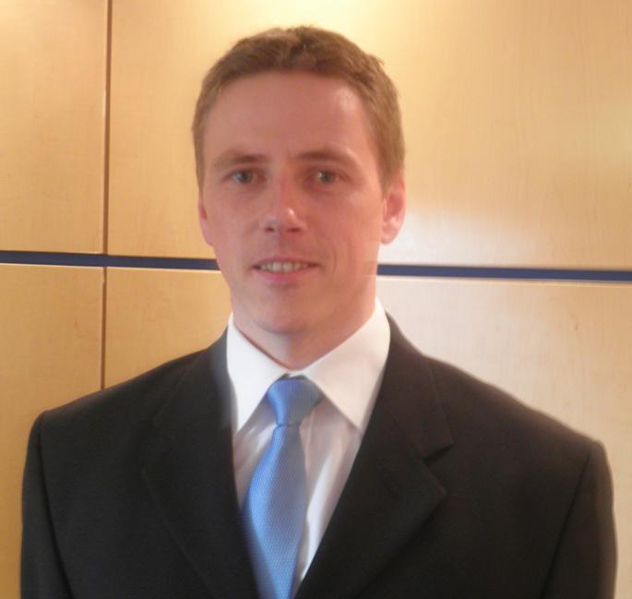Born in 1973, I have lived in Alloa, Clackmannanshire all my life with the exception of the six years I spent in the Royal Air Force.

I am married to Lesley-Anne and have three fantastic kids, Conall (9) Callum (2) and Caiti-Anne (1). In my spare time I coach a local football team, Wasps Community Club under 10’s (Conall plays for them), cooking and trying to keep up with our babies!

I left school at sixteen with three standard level GCSE’s and worked on a youth training scheme for two years prior to joining the RAF in 1991 as an airframes engineer. I spent six years based at RAF Leuchars and travelling around the world on 111 (F) Sqn which included two tours of duty for NATO forces during the Bosnian conflict. I was offered further promotion in 1996. At that point I applied to join Central Scotland Fire Brigade.

I joined the Fire Brigade (now Central Scotland Fire and Rescue Service) in 1997. Since then I have completed all promotional exams and was promoted to the rank of Watch Manager. I went to college in 2005 and studied toward an HNC in Watch Management. I progressed further and personally financed my studies, culminating in gaining my MBA in 2009, completing my dissertation in Performance Management within the Fire and Rescue Services.

I have recently been promoted to the rank of Station Manager (equivalent to Inspector in Australia) within the Risk Department. My references are Operational and Community Risk which involves identifying risks to our personnel and the community and introducing control measures. I am currently working on an Operational Intelligence gathering system. The system will ensure that our crews have information on risks including site plans, utilities and significant hazards on our touch screen systems which are fitted in the fire engines. The crews will access the information en route to the incident.

I would be grateful if I could study the Fire and Rescue Service New South Wales. I would like to study the Service at all levels. In terms of the operational level I would like to spend a shift with a crew to gain an insight into their working day/night and get an idea of their impression of the Service. I would also be interested in the cultures at Station level.

In terms of middle management I would also like to study their intelligence gathering systems, how they deal with known risks and how they gain intelligence on unknown risks. The current structure of eight Fire and Rescue Services within Scotland is currently being reformed into one Scottish Fire and Rescue Service (due in 2013). The new service will serve a population of five million Scots covering a land mass of 30,000 square miles. Although the populations are similar, the land mass of NSW is ten times larger.

In this regard I would be grateful if I could spend some time with Strategic Managers and study the governance arrangements the Service has. I would hope to gain an insight into both the advantages and disadvantages of such a large Service.

**e-mail** [**lesleyandmark@talktalk.net**](mailto:lesleyandmark@talktalk.net)

**Mob 07866 100817**

**Work 01324 716996**

**e-mail mark.bryce@centralscotlandfire.gov.uk**

**Home 35 Delaney Court, Alloa, Clackmannanshire**

**FK10 1RA 01259 722928**

**JAMIE HARRISON D1010 Team Member**

I am 38 years old and live in Rothienorman, Aberdeenshire. I have been happily married to Hazel for 9 years and have three daughters, Kirsty (8), Rebecca (3) and Caitlin (2)

.

I studied Civil Engineering at Aberdeen University, graduating in 1994. I spent a year working as a civil and structural engineer in Bo’ness, but in 1995 left to return to Aberdeen and join Grampian Police. In my spare time I enjoy fly fishing and competing in triathlons. I am president of the Grampian Police fly fishing section and vice chair of Three Peaks Triathlon club. Our club organises several local races and we are in the process of introducing a youth’s triathlon event.

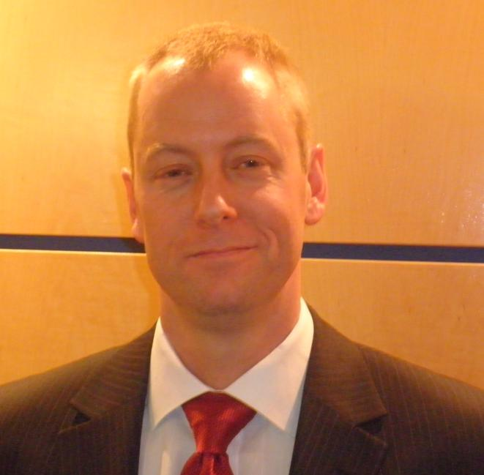On joining Grampian Police, I spent my first 4 years working as a uniformed constable at various stations around Aberdeen. In 1999 I transferred to work within a proactive unit, working on house breaking and drugs enquiries. I later moved to the divisional Criminal Investigation Department, where I initially undertook general CID duties before moving to a local Intelligence Office, where among other things I was a source handler. This role involved the identification and recruitment of police informants. Throughout this period, I was also a firearms officer and a football ‘spotter’. Here I attended Aberdeen Football Club matches and identified known football 'hooligans' to local police. I was promoted to sergeant in 2006 and was assigned the role of detective sergeant in Grampian Police's Major Investigation Team. I was responsible for supervising a team of detectives, investigating major enquiries and murders within Grampian. I am a Crime Scene Manager, having responsibility for the direction of police, specialist and forensic services at scenes of crime and major incidents.

I returned to divisional policing in 2010 and enjoy working as part of the local policing team at Inverurie. I attend Community Council and planning meetings, and sit on a working group aimed at improving the effectiveness of Community Councils.

From participation in the Group Study Exchange program I hope to broaden my knowledge of policing and find out about the differing legal processes in Australia. I am very supportive of Grampian Police’s current policy of community focus and the use of local policing teams. I would be interested to ascertain if there are similar policies in Australia. I would be interested to learn about the specifics of Project Eyewatch and its success to establish if similar measures could be utilised in Grampian Police in furtherance of our community focus priority.

I am a keen triathlete and am interested in the sporting culture that exists in Australia. In particular I have read of the ‘Wagga effect’ and as such would like to visit sporting complexes to learn about the excellent facilities and opportunities that exist.

Ultimately the Group Study Exchange will broaden my experience of policing in the global workplace, arming me with a greater knowledge and frame of reference from which to base my decisions. I would hope to obtain more ideas and best practice that I could take back and utilise to the benefit of my community and Grampian Police.

**Jamie Harrison**

**Rotary District 1010 GSE Team Member 2012**

**Brigend, Rothienorman, AB51 8UH, United Kingdom**

**Voice: +44 (0) 1651 821113 Mob: +44 (0) 7546 472651**

**Email:** jamiedharrison@btinternet.com