**CONGRATUALTIONS TO COOLAMON ROTARY CLUB 50 YEARS**

Can I be late in wishing the Coolamon Rotary Club a fantastic day celebrating 50 glorious YEARS.

The connections between Coolamon and Hout Bay Rotary RC goes back many years. Phone calls in the middle of the night to Butch Liebenberg and to me by John Glassford which resulted in the most exciting, rewarding. worthwhile, and embracing every possible reason why ROTARY is truly the organisation that serves all those who are less fortunate and is the VERY BEST.

Strangers from Australia arrived in Africa (well not John of course) to help in so many ways, perhaps many were hopeful of spiritual guidance as they insisted on climbing mountains to get nearer to their dreams. In Hout Bay we were a little closer to the ground but quickly learnt the importance of understanding what Coolamon was. The generosity of those climbers will be forever remembered and why the Hout Bay Club toasts Coolamon at every meeting.

We in Hout Bay Rotary have played a small part in the 50 years of Coolamon Rotary but we do sincerely hope that Coolamon Rotary Club while reflecting on their 50 years will always find a space to remember Hout Bay Club and we salute the Coolamon Club and its members with a particular special mention of PDG John Glassford whose enthusiasm, dedication, drive and bloody hard work has never been forgotten.

**COOLAMON ROTARY CLUB CONGRATULATIONS FROM ALL OF US AT HOUT BAY.**

I mentioned Nonceba because the Australians visited the Nonceba old centre and they sat in quietly on a counselling session, there were few dry eyes as the listened to the story from a young rape victim. But what is really so special is the international aspect of Rotary the amazing help we have had from Rotarians at Clubs around the world.

Coolamon is such a remarkable example.

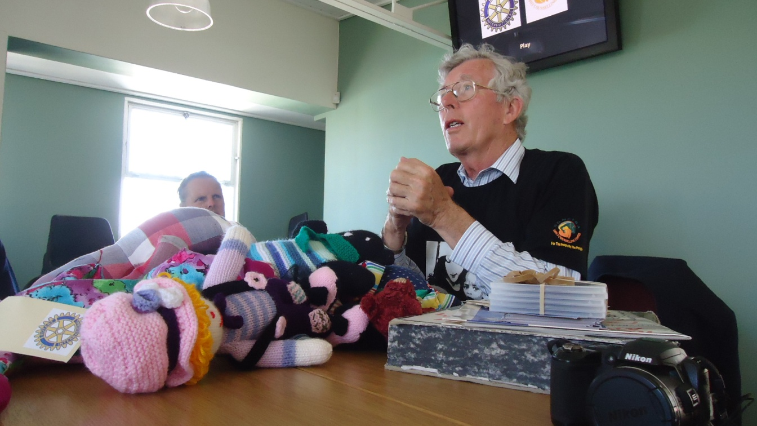

**PP Don Peters Hout Bay RC**

Hi John, from Nelson Bay, NSW.

Yes, indeed how things change, but that's Africa for you.

Who can forget that magnificent Coolamon/Glassford invasion of Hout Bay, and those pioneering Ozzie's who came to see the problems of Africa at first hand, the projects of Hout Bay Rotary Club and the shocking conditions in the squatter camps?

The resulting contribution of Australian Dollars into the Hout Bay welfare account made a vast difference to the children's feeding schemes and the extended clinic to service the increasing AIDS population.

Such is the power of Rotary and Rotary International and such is the power of friends across the sea.

Enjoy your Fifty years and celebrate hard, you deserve it.

Best Wishes and thanks for such wonderful memories.

Dave and Sylvia Heath.

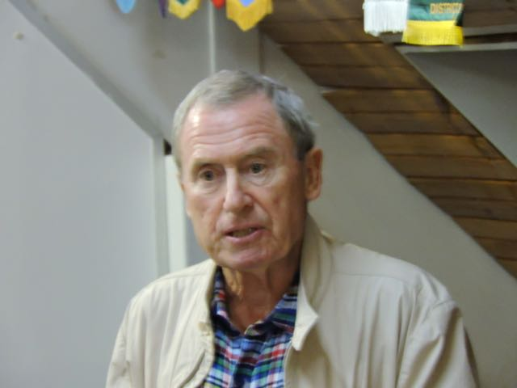

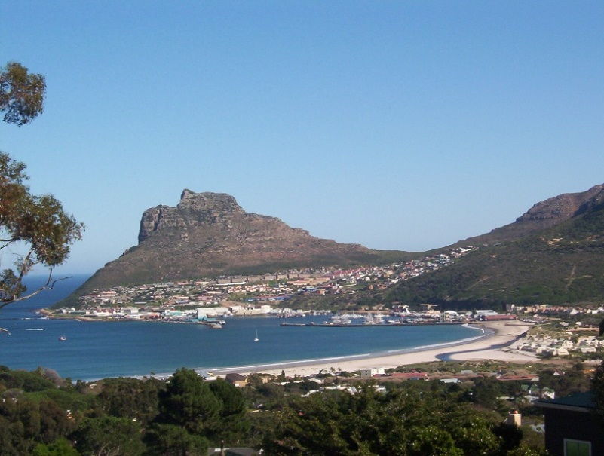

Hi John,

As Lyn and I had the pleasure of visiting Coolamon Club 4 years ago, representing Hout Bay Rotary , I felt a few short words were called for.

Congratulations on your clubs 50th Birthday celebrations. I remember clearly your and Sues visit to Hout Bay some years back promising to climb mountains to raise funds for both Hout Bay Club and others. You spoke from your heart, leaving us with full confidence that you and your team would climb Mount Kili resulting in funds pouring into our coffers.

The result was the building of the extensions to the Clinic near IY, which I personally worked on and supervised. It was an amazing gesture from Coolamon Club .From memory we received USA100,000 Dollars from you which converted to around R1,000.000.

Lyn and I wish you a great evening .please say hi to all the wonderful people we met.

Best wishes

PP Butch Liebenberg

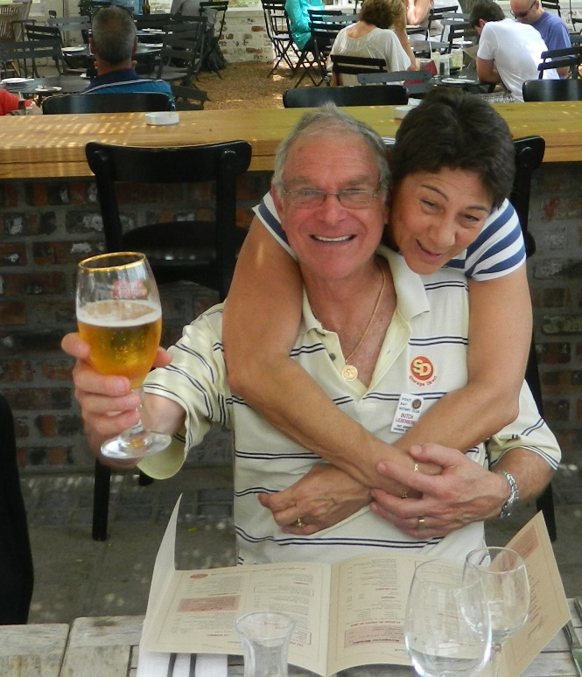

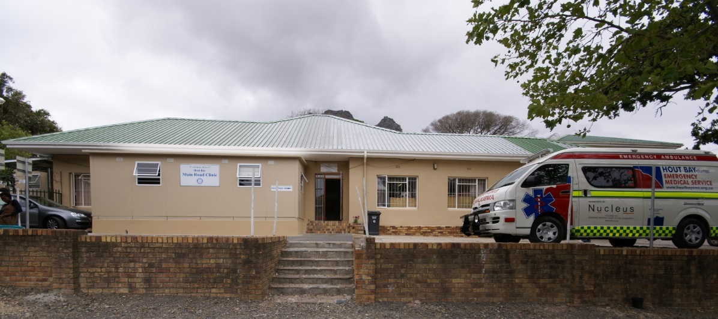

**Coolamon House Hout Bay Clinic**