**THE HEY TWINS GANMAIN**

Dick Jennings recently visited the Ganmain Bakery and found out about the Hey twins from Ganmain. The Ganmain Bakery has organised a hamper to raise money for the continued costs that these twins face in the future.

Their grandmother has a GoFundMe page up and running as well.

Dick and I are recommending that the Board approve a donation to the Hey family, (amount to be decided by the Board), to support their ongoing costs for treatment in Canberra for these children.

John G will learn more about their situation. However, the following information is tabled here for your consideration.

**KERRIE HEY GRANDMOTHER**

Hi, my name is Kerrie Hey and I am fundraising for Joshua and Brittney Hey.

On the 13/1/23 At 25 weeks pregnant Britt was urgently flown to Canberra from Wagga very urgently. Josh followed straight away.

Britt gave birth the next morning to 2 beautiful little boys. They were born at only 730 & 765g. They are doing well considering their gestation but they have a long journey ahead of them.

They had nothing but the clothes on their backs initially. They have had to restart life in Canberra with a huge unknown journey in NICU with no clear definite end in sight!!

NICU is a hard, long & lonely road and puts a huge stress on you in every way…. Emotionally, physically, mentally & financially….

The bills don’t stop, they still have a house to keep up so they have a home to go back to, they need to buy essentials for the boys they didn’t have time to get and they need to cater for ongoing medical costs beyond being discharged and for time when they have to go back and forth to Canberra for medical appointments.

Please help this gorgeous couple out in any way you can!! A little goes a long way xx

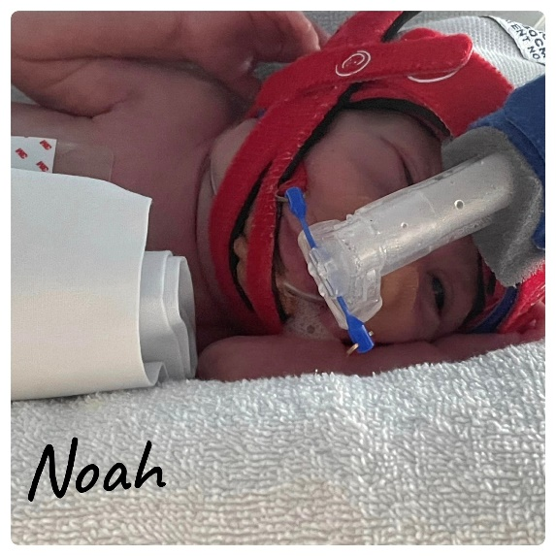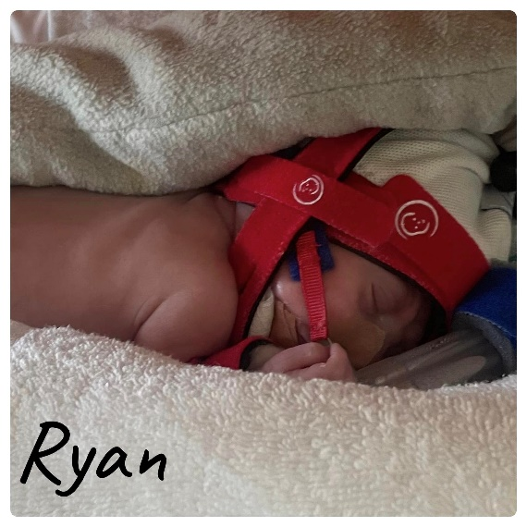

**4th May Update**

Ryan is doing so much better, he is getting bigger and stronger every day, the doctors are watching his heart rate carefully, in 2 weeks his eyes will be checked again and then if they are improving we will be able to be transferred to Wagga.

Noah is now on 4 bottles a day as he continues to drink them all my little chunky boy, they are slowly weaning his oxygen as they don’t want to rush both boys.

You boys are 4 months in 9 days and my heart is full watching you grow and still not believing [Joshua](https://www.facebook.com/joshua.hey.9?__cft__%5b0%5d=AZWzNA0M8FdV42UFl0qekAeLto91yfzzs7jEetaR-7HBmRCUYbJHv14rvyvxQ_QuS3WcsAxICnanKxjTsuFGI1ETbgNpt4Ph8FiERoWLmtcDrUOrbwOF522ZhSTU7WWoyXwQQD7uXV7RyEyhfvXMAVvlfSESz6ANo8NP3V1005rotfpKGjLxSDiDsSKx-m-D9_LCBMxdPRYgxXLdcMF5ip_W&__tn__=-%5dK-y-R) and I have two beautiful boys and giving [Isaac](https://www.facebook.com/profile.php?id=100091729988570&__cft__%5b0%5d=AZWzNA0M8FdV42UFl0qekAeLto91yfzzs7jEetaR-7HBmRCUYbJHv14rvyvxQ_QuS3WcsAxICnanKxjTsuFGI1ETbgNpt4Ph8FiERoWLmtcDrUOrbwOF522ZhSTU7WWoyXwQQD7uXV7RyEyhfvXMAVvlfSESz6ANo8NP3V1005rotfpKGjLxSDiDsSKx-m-D9_LCBMxdPRYgxXLdcMF5ip_W&__tn__=-%5dK-y-R) some more siblings, I’m so protective over you now and I can’t wait to see what I’m like when we leave the hospital.

If you got down this far, here’s a little secret the boys are being transferred to paediatrics where we will be able to do all cares and feeds ourselves with the help of nurses and hopefully Isaac will meet them soon.

**GANMAIN BAKERY HAMPER**

**Anna and Tracey from the Ganmain Bakery with the twins last Saturday.**

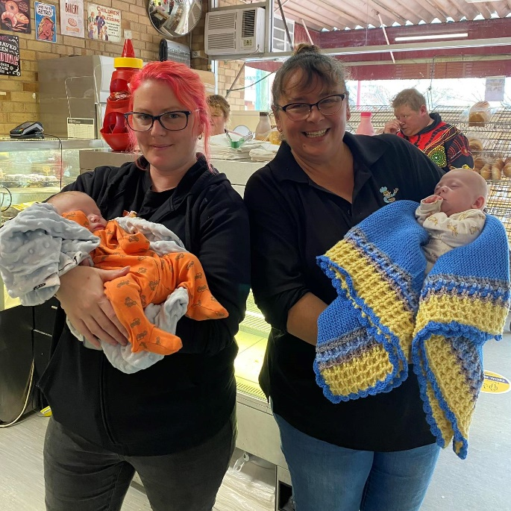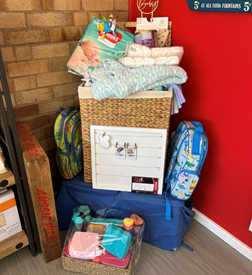

They are home! Such fantastic news! Both boys doing very well.

Thank you, Josh and Brittney, for stopping by and letting us have cuddles

Absolutely made our day

The Hey Family~

The basket 🧺at the bakery is coming along nicely.

We are so happy to announce Ryan & Noah have been transferred to Wagga hospital 😁.

We will hand these goodies over to mum and dad while they prepare to bring these babies home.

We are hoping to hand everything over this Saturday so if you have been wanting to contribute, there is still time.

Thank you to everyone that has contributed to this beautiful hamper.

It is very much appreciated 💖

Nearly home baby boys